Robustness Diagrams

Contents

[Create Employee (By Dean) 2](#_Toc481254055)

[Delete Employee (By Dean) 2](#_Toc481254056)

[Edit Employee (By Dean) 3](#_Toc481254057)

[Login (By Mahtarr) 3](#_Toc481254058)

[Order New Stock (By Mahtarr) 4](#_Toc481254059)

[Checking Stock (By Mahtarr) 4](#_Toc481254060)

[Create Supplier (By Dan) 5](#_Toc481254061)

[Delete Supplier (By Dan) 5](#_Toc481254062)

[Edit Supplier (By Dan) 6](#_Toc481254063)

[Create Client (By Dan) 6](#_Toc481254064)

[Edit Client (By Dan) 7](#_Toc481254065)

[Delete Client (By Dan) 7](#_Toc481254066)

[Get delivery status (By Fraser) 8](#_Toc481254067)

[Check available (By Fraser) 8](#_Toc481254068)

[Type of work completed (By Fraser) 9](#_Toc481254069)

## C:\Users\FraserGamingPC\AppData\Local\Microsoft\Windows\INetCache\Content.Word\CreateEmployee.pngCreate Employee (By Dean)

## C:\Users\FraserGamingPC\AppData\Local\Microsoft\Windows\INetCache\Content.Word\DeleteEmployee.pngDelete Employee (By Dean)

Edit Employee (By Dean)

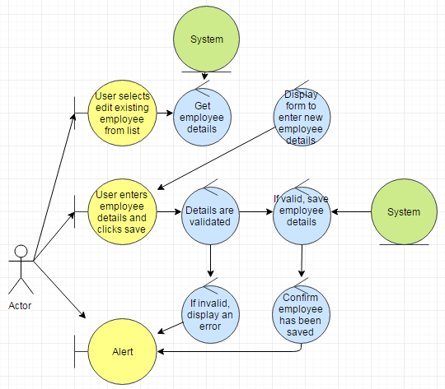

## Login (By Mahtarr)

C:\Users\FraserGamingPC\AppData\Local\Microsoft\Windows\INetCache\Content.Word\Login_Robustness_Diagram.png

## Order New Stock (By Mahtarr)

C:\Users\FraserGamingPC\AppData\Local\Microsoft\Windows\INetCache\Content.Word\order_new_stock_robustness_Diagram.png

Checking Stock (By Mahtarr) C:\Users\FraserGamingPC\AppData\Local\Microsoft\Windows\INetCache\Content.Word\checking_stock_robustness_Diagram_(1).png

## Create Supplier (By Dan)

C:\Users\FraserGamingPC\AppData\Local\Microsoft\Windows\INetCache\Content.Word\Create_supplier2.png

Delete Supplier (By Dan) *C:\Users\FraserGamingPC\AppData\Local\Microsoft\Windows\INetCache\Content.Word\Delete_supplier.png*

## Edit Supplier (By Dan)

*C:\Users\FraserGamingPC\AppData\Local\Microsoft\Windows\INetCache\Content.Word\Edit_supplier.png*

## Create Client (By Dan)

C:\Users\FraserGamingPC\AppData\Local\Microsoft\Windows\INetCache\Content.Word\Create_client2.png

## Edit Client (By Dan)

C:\Users\FraserGamingPC\AppData\Local\Microsoft\Windows\INetCache\Content.Word\Edit_client2.1.png

## Delete Client (By Dan)

C:\Users\FraserGamingPC\AppData\Local\Microsoft\Windows\INetCache\Content.Word\Delete_client2.png

## Get delivery status (By Fraser)

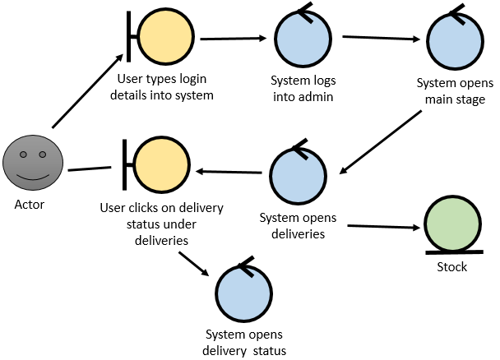



## Check available (By Fraser) C:\Users\FraserGamingPC\AppData\Local\Microsoft\Windows\INetCache\Content.Word\type of work completed.png



## Type of work completed (By Fraser)

